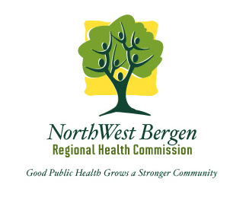
NorthWest Bergen Regional Health Commission
20 W Prospect Street * Waldwick, NJ 07463
Phone: 201-445-7217 * F ax: 201-445-4001
Website: www.nwbrhc.org
Facebook: www.facebook.com/NWBRHC

NORTHWEST BERGEN REGIONAL HEALTH COMMISSION
SEEKS A FULL-TIME REGISTERED ENVIRONMENTAL HEALTH SPECIALIST (REHS)

Under the direction of the Health Officer, responsibilities include, but are not limited to: conducting field inspections and complaints, enforcement of state and local codes regarding public health nuisances, retail food establishments, communicable disease, potable water systems, public recreational bathing facilities, body-art facilities, youth camp facilities and pet shops/kennels. Lead Inspector/Risk Assessor certification a plus. Documents case findings and collects evidence in preparation of corrective action.
Qualified candidates include those individuals who have a valid NJ REHS license and a valid NJ driver’s license and vehicle.
Successful candidate must have strong communication and writing skills and be proficient at both written and electronic reporting methods. Three years’ experience in a local health department is required.
Salary commensurate with experience.
To apply, please send resume with cover letter to Judith Migliaccio, Health Officer, by email to jmigliaccio@nwbrhc.net.

