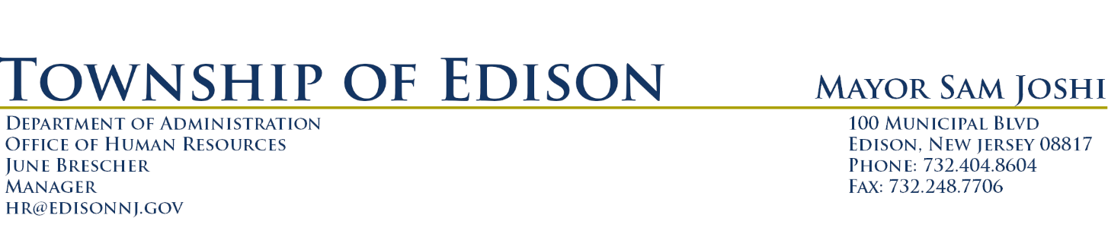
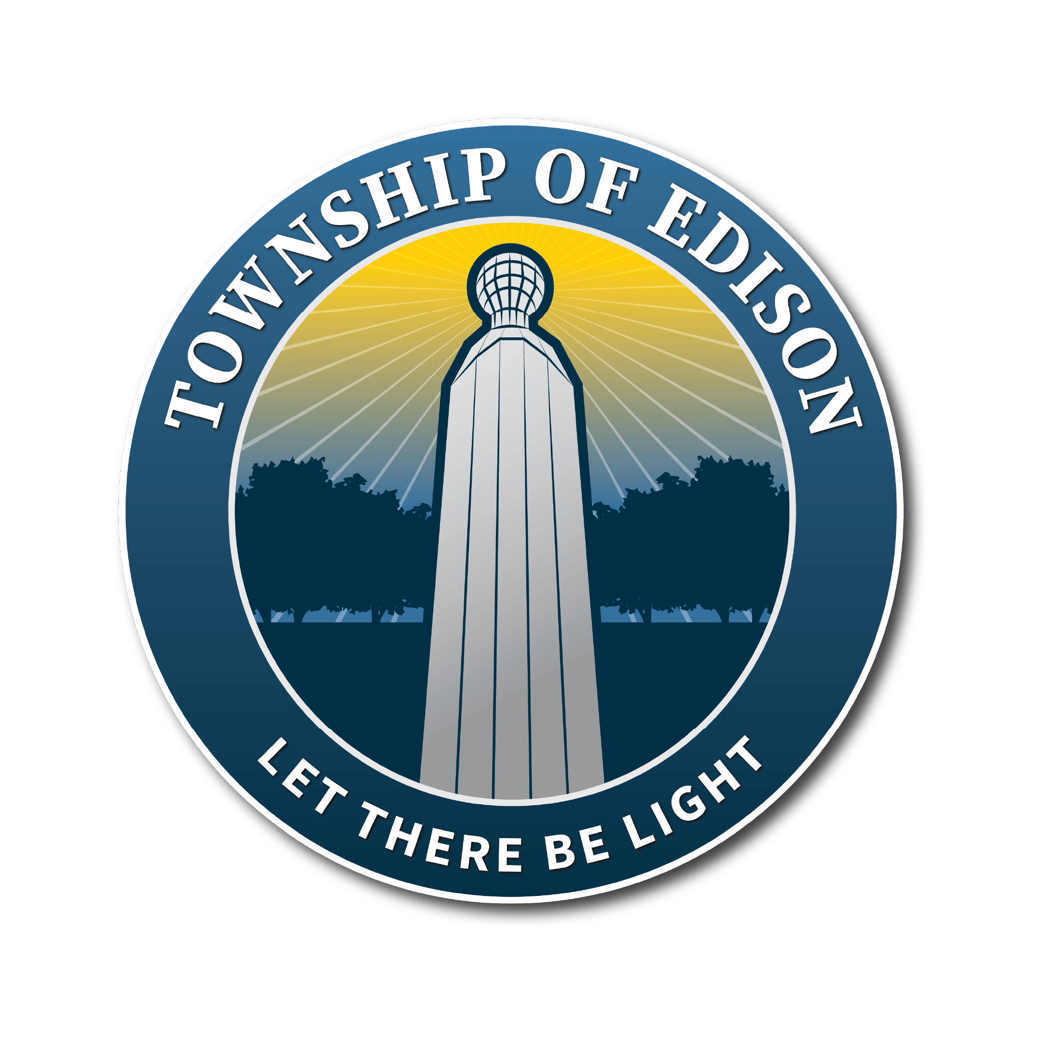

DIRECTOR OF HEALTH AND HUMAN SERVICES

Director of Health and Human Services Department is the head of four important health functions of the Township, Division of Health, a Division of Welfare, a Division of Human Services and a Division of Senior Citizen Services. Departmental responsibilities include administering the business connected with the enforcement of the ordinances and regulations of the Department of Health and Human Services and the laws of this State which relate to the public health, the inspection and protection of the food supply, the investigation and abatement of nuisances and conditions affecting the public health, the investigation and enforcement of the sanitary conditions of public and private buildings and premises, the collection and keeping of vital statistics and the records of the Division of Health, and the dissemination of information relating to public health matters. Ideal candidate has degree in health, social services or related field, 3-5 years’ experience in human and health services with a demonstrated experience in personnel management. Health Officer License required but may be obtained within the first two years of employment.

Qualified applicants may electronically submit cover letter, current resume and salary requirements to HR@edisonnj.org.

